**Assignment Report**

EGBE 443Image Processing in Medicine

1. **Develop program to read an image and Convert RGB to gray scale image**

I required OpenCV library or cv2 module to read an image and convert to gray scale by use cv2.imread function. This function required 2 variable such as filename and mode. I select mode 0 to convert RGB to gray scale image

1. **Create function for computing histogram and cumulative histogram**

def calculateHistogram(img):

    list_img = []

    intensity = [0 for i in range(max_intensity)]

    for row,index in enumerate(img):

        list_img = np.concatenate((list_img,index))

    for i in list_img:

        intensity[int(i)] +=1

    return intensity

I developed calculateHistogram function to calculate histogram manually. To use this function, I have to pass 1 parameter, img which is 2D arrays that return from cv2.imread mode 0, then I concatenate the index, pixels value, from img into list_img and calculate how many in each pixel value that have been counted

def calculateCumulativeHistogram(intensity):

    cumulative = [0 for i in range(max_intensity)]

    for i in range(max_intensity):

        if(i == 0):

            cumulative[i] = intensity[i]

        else:

            cumulative[i] = (intensity[i] + cumulative[i-1])

    return cumulative

I used calculateCumulativeHistogram function to calculate cumulative histogram by entering 1 parameter, intensity which is list that return from calculateHistogram function.

1. **Demonstrate your developed functions with at least two images** **and from the images and their histograms explain in formation that you gain from them**

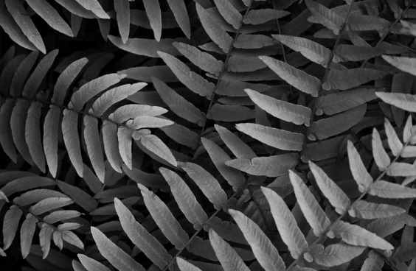

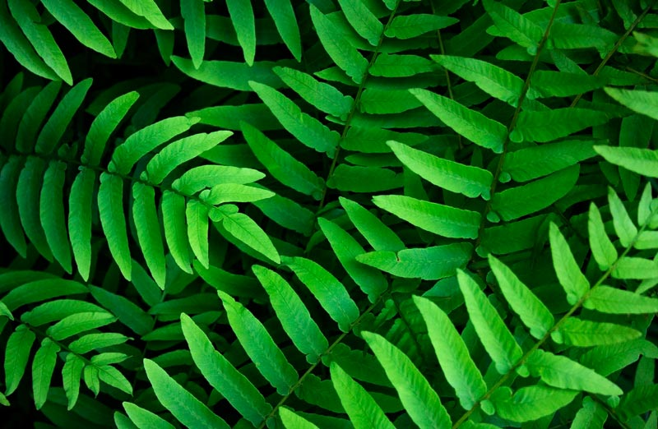

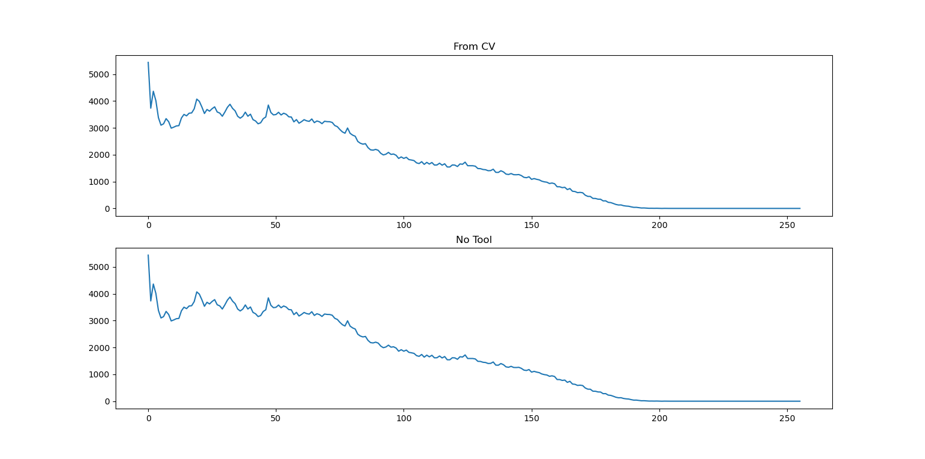 **Fig. 1** Image 1(24-bit depth, RGB) **Fig. 2** Image 1 Converse to Gray scale by OpenCV

**Fig. 3** Compare histogram that use tool and my developed function of Image 1

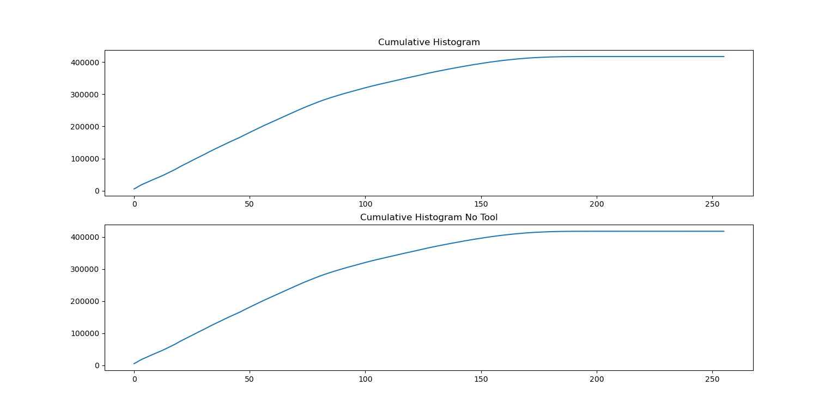

**Fig. 4** Compare cumulative histogram that use tool and my developed function of Image 1

From the Fig. 3 and Fig. 4, I found that histogram and cumulative histogram of the image from using toolbox and using my developed function is the same. And I gained that the Image 1 is quite dark because this image is underexposed, saturation and most intensity values are in very dark tone and this histogram shown that Image 1 has not gap and spike.

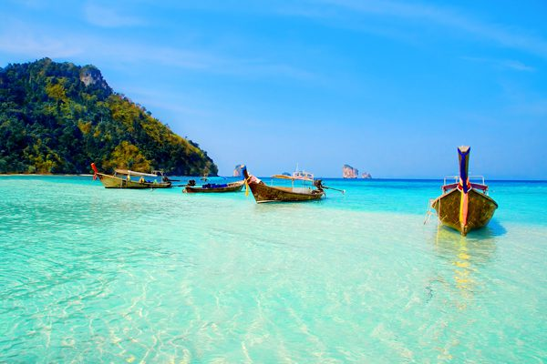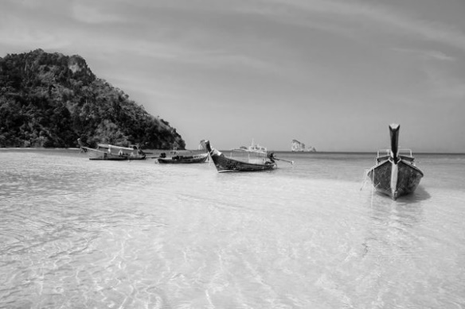

**Fig. 5** Image 2(24-bit depth, RGB) **Fig. 6** Image 2 Converse to Gray scale by OpenCV

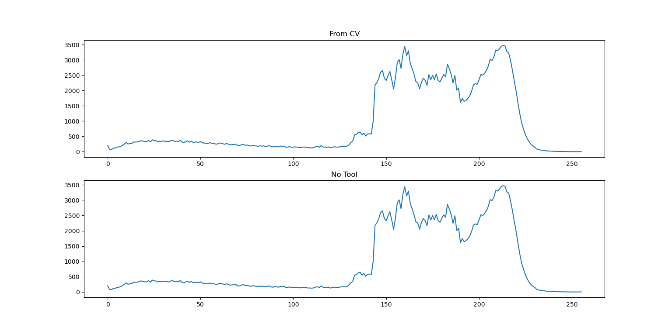

**Fig. 7** Compare histogram that use tool and my developed function of Image 2

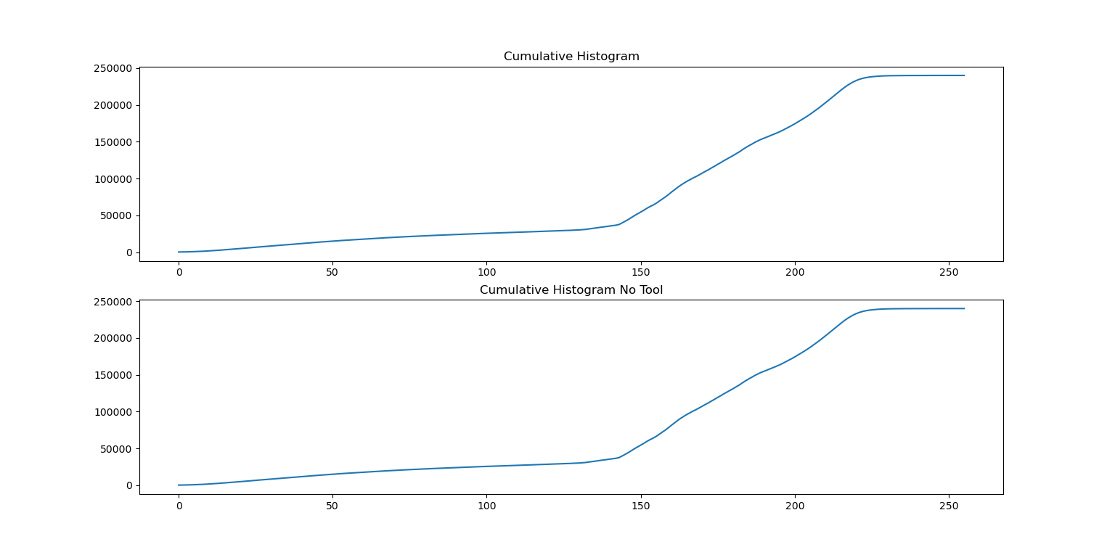**Fig. 8** Compare cumulative histogram that use tool and my developed function of Image 2

From the Fig. 7 and Fig. 8, I found that histogram and cumulative histogram of the image from using toolbox and using my developed function is the same. And I gained that the Image 1 is properly exposed, no saturation, no gap and spike and the most of intensity values are in light tone

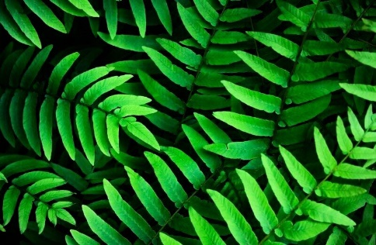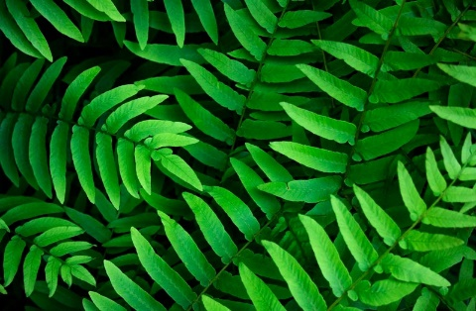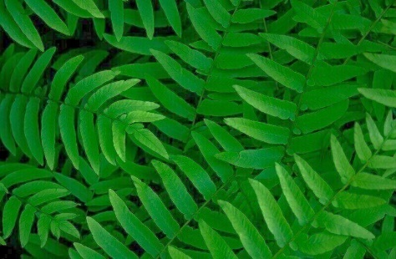

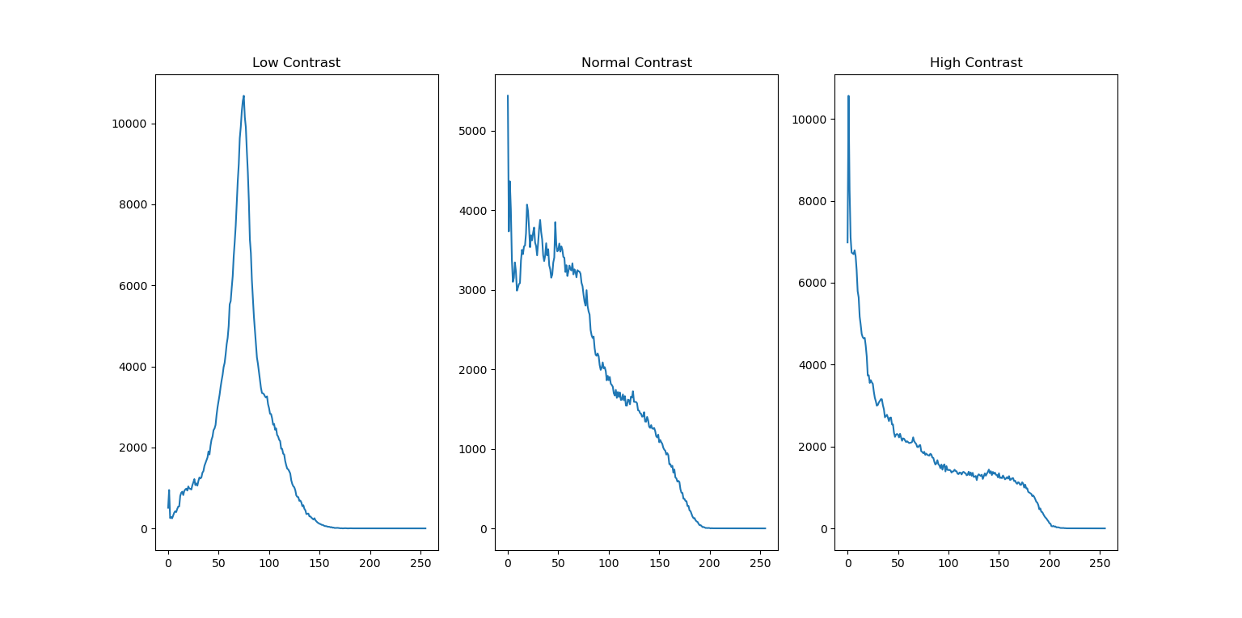 **Fig. 9** Low Contrast  **Fig. 10** Normal Contrast **Fig. 11** High Contrast

**Fig. 12** Compare histogram from difference contrast (Low contrast, Normal contrast and High contrast)

From the above Figure. I found that the low contrast image has lowest range of intensity as shown in the right graph of Fig. 12. The high contrast image has highest range of intensity as shown in the left graph of Fig. 12. And the normal contrast image is depicted as shown in the middle graph of Fig. 12